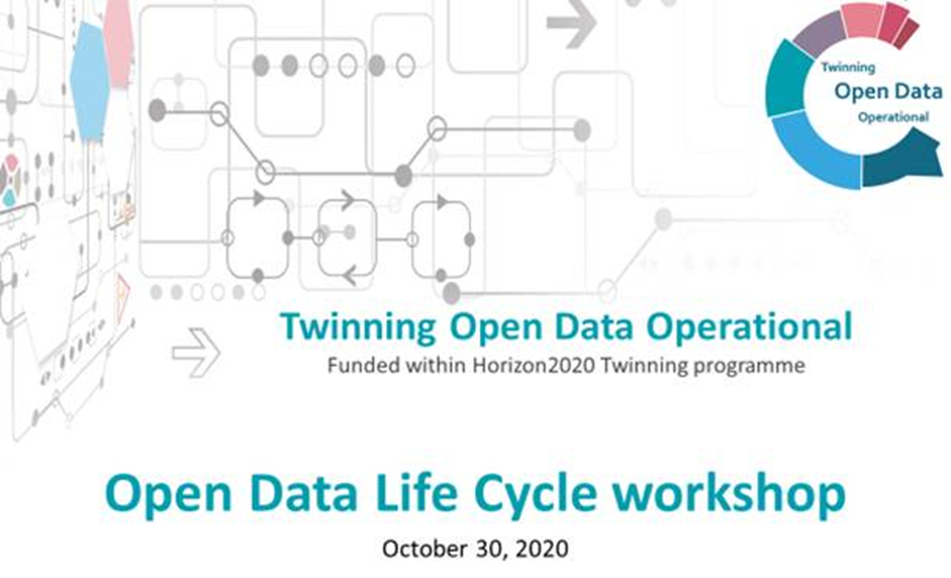

**Final program**

**Session 1 (10:00-11:45)**

* *TODO project and Open data life cycle workshop introduction*: Assist. Prof. **Ana Kuveždić Divjak**, Faculty of Geodesy University of Zagreb, Project coordinator
* *Welcome address:* Assoc. Prof. **Almin Đapo**, Dean of the Faculty of Geodesy University of Zagreb
* *Opening address:* Mr. **Bernard Gršić**, dipl. ing. el., State Secretary at the Croatia’s Central State Office for the Development of Digital Society
* *Open Data Ecosystem in Europe:* Prof. **Joep Crompvoets**, KU Leuven, Public Governance Institute & EuroSDR General Secretary
* *Open Data in the Circular Economy*: Prof. **Marijn Janssen,** Technology, Policy and Management Faculty, Delft University of Technology
* *Open Data Governance:* Prof. **Melanie Dulong de Rosnay,** Director of the Center for Internet and Society,French National Centre for Scientific Research

**Session 2 (12:00-13:30)**

* *Open Data Reusers in the Picture:* Prof. **Frederika Welle Donker**, Faculty of Architecture and the Built Environment, Delft University of Technology
* *Open Data Strategies and Practices at National Level: Lessons from EU Member States:* Prof. **Yannis Charalabidis**, Department of Information and Communication Systems Engineering, University of the Aegean
* *Open Data in Croatia:* Assoc.Prof. **Anamarija Musa**, Faculty of Law University of Zagreb

**Session 3 (15:00-16:15)**

* *EU Data Portal*: **Gianfranco Cecconi**, Lead of the European Union’s Data portal and support centre for data sharing projects
* *The Emergence of a Third Wave of Open Data?*: Prof. **Stefaan G. Verhulst**, Co-Founder and Chief Research and Development Officer of the Governance Laboratory ([The GovLab](http://thegovlab.org/)) at New York University
* *TODO project – further steps and call for cooperation*: Assist. Prof. **Ana Kuveždić Divjak**, Project Coordinator, Faculty of Geodesy University of Zagreb